Waveshed by Joe Magee (periphery.co.uk)

Cultural cinema and digital creativity centre in Bristol UK

Content Creator, Rife magazine

"The staff and the vibe at Watershed are what keeps me coming back..." Phill Jupitus.
“Working for Rife has been an amazing experience, I’ve had the opportunity to create content around issues I feel passionate about, as well as developing new skills.”
Adibah Iqbal, Young Journalist Rife magazine
“It’s just an amazing experience. You can really push your skills to the limit!”
Ryan Francis, Young Journalist Rife magazine
Position: Content Creator , Rife magazine
Post- holder:
Grade: £11,700 per annum 30 hours a week (50% office hours and 50% evenings & weekends) 6-month contract (£5,850 for the 6 months of the contract period before deductions).
The boss: Online Editor
What’s the Job?

We want three young content creators to come join us for six months in a paid role where you make content for Rife magazine - blogs, articles, videos, photos about what’s important to young people in the city. In return, you get mentored by an experienced team of creatives to develop your portfolio and networks.

What Exactly Will You Be Doing?

- Reporting on activities and stories in the city that are important to young people
- Capturing, writing, editing and publishing image and video content
- Curating online content by young content creators in Bristol
- Taking an active role in the online content editorial team
- Advising on the development of Rife
- Being an advocate for Rife, in peer mentoring sessions and at events
- Attending / fulfilling training requirements and personal development targets to further personal development.
- Adopting safe working practices at all times, conforming to all relevant Health and Safety procedure and attend relevant training.

How Do We Measure Your Progress?

- Rife magazine is kept up-to-date and active with connected content from young people across the city
- You successfully develop communication skills and positive working relationships with Watershed staff, young people and associated partners
- You demonstrate the desire to learn and develop new skills and knowledge by actively engaging with mentor support and training
- Your confidence improves and so does your awareness of the choices available to you to develop your career
- You produce timely and accurate feedback and reporting as requested.

What we are looking for?

- Good media production and/or writing skills
- Good level of IT literacy (preferably on Mac)
- Confident user of social media
- Shows initiative and positive approach to problem solving.
- Proven ability to work independently under direction and as part of a team.
- An interest in digital media and youth issues

Watershed Values
The Watershed brand is unique, trusted and respected and is driven by the following shared values which are clearly articulated. Ability to master and represent Watershed’s Vision and Values is therefore important.

Watershed is:

People Led | People are the engine of our organisation. We will never forget that we are here for the people we work with and for – without them Watershed would not exist.
Entrepreneurial | We create opportunities, incubate ideas and take risks to explore new ways of looking at, and doing, things.
Make Things Happen | Through partnership, innovation and exchange we make things work and aspire to excellence.
Open and Honest | We provide a culture and environment that is trusting, trusted and trustworthy.
Celebratory | At the heart of our offer is the celebration of culture, diversity, creativity and wonder.

Watershed encourages applications from people of all backgrounds but particularly encourages applications from candidates from a BAME background as they are currently under-represented within our staff team.

Additional information:

- The post-holder is expected to wear clothing appropriate to their post.

- The post-holder will be required to undertake such other comparable duties as may be required by the Head of Department'.
- Watershed is open seven days a week, including Bank Holidays (Christmas Day and Boxing Day are the only exceptions). Watershed is a public building, which operates a diverse range of cultural and commercial activities. The post holder will need to be comfortable working in this environment.
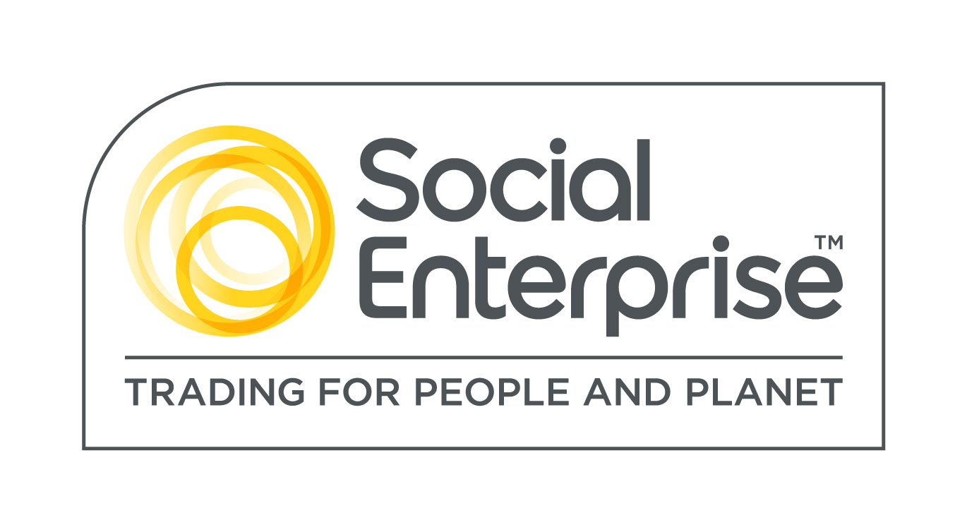
Watershed is a Social Enterprise Mark holder. Social Enterprises are businesses whose products and services create both social and environmental benefits.

Watershed is striving to be an equal opportunities employer.

Signed (Line manager):
Signed (Employee):
Date:

Appendix

Specific Duties

A. CONTENT PRODUCTION

- Attend weekly editorial meetings to discuss content plan for the following week
- Assist with the curation of the content schedule and ensuring that you know what you’re responsible for
- Curate the social media streams, taking up the task of being community builder as well as uploader.
- Curate and start conversations, join in discussions and use social media to promote the content
- Write, record, edit and upload your story as per the content schedule
- Help your colleagues as and when
- Act in a professional manner when dealing with interviewees, members of the public, PR departments and providers. Or anyone for that matter
- Work with associates to ensure that their voices are being heard, their suggestions of stories are being worked on and that they are given space to provide content. Work with them to create content for the site
- Work with pitchers who want to get their voice heard on the site. Work with them on content ideas.
- Support with organisation and delivery of outreach workshops, talks and networking events
- Work with industry professionals from partner organisations to create content with young people about issues important to them

B. DIGITAL ASSISTANCE

- Feed back to the editorial team on what’s trending, what’s happening in Bristol and what local issues are hot button topics that week in the news, locally and online
- Collecting and archiving cuttings and screengrabs of press, prominent interactions and success stories from all content produced
- Providing monthly analytics from website traffic and social media interactions
- Using web statistics to analyse how to improve reach, not only through content but also through keywords, promotion, strategic placement online
- Finding and attending networking and training opportunities
- Sending out a regular email to all providers informing them of latest content and also liaising with providers/partners for potential content

C. GENERAL

- Look after equipment, sign it out and ensure maintenance
- Be respectful of Watershed staff and adhere to their policies around health and safety, IT usage and equality
- Take part in meetings and training as appropriate
- Keep an up-to-date log on the board in the office of when you are in and out
- Advise on branding and promotion of site
- Keep abreast of current and future digital trends and how this may work for Rife magazine.

